|  |  |  |  |
| --- | --- | --- | --- |
| Name:  Teacher : | ____________________________________  ______________________ | | Date:_________ |
|  | **Year 12 Essentials**  **Area and Volume investigation - Validation**  ***Full working out MUST be shown to get full marks for each question.*** | | |
| **Total Time:** | 55 minutes |  | |
| **Weighting:** | 5% |
| **Equipment:** | To be provided by the student: Pen, pencil, ruler, scientific calculator, INVESTIGATION PART 1 | | |

/27

Farmer Kath has chosen to build the chicken coup below. Find the total surface area of the newly designed chicken coup. [9 Marks]

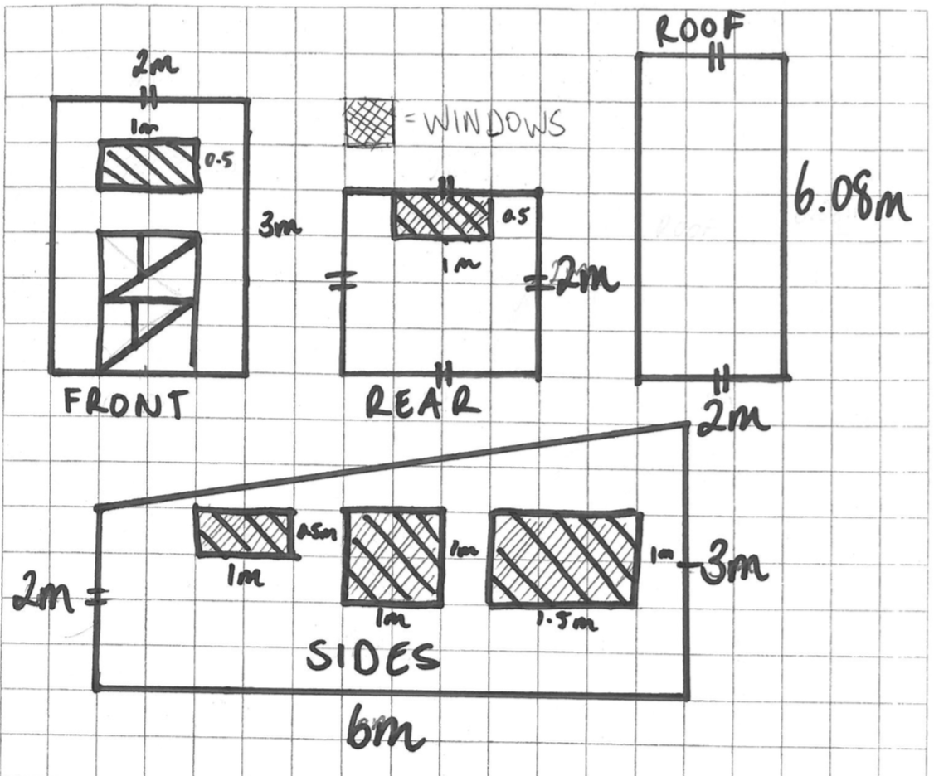

If she was going to build this coup, and paint it, how much would it cost to build in total? [7 Marks]

She uses her fencing to build a U-Shaped field. Find the total Area of the field. [3 Marks]

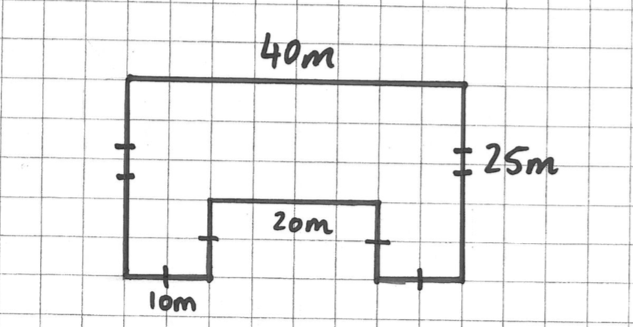

Farmer Kath decides she needs to be able to store more water. She has two options:

1. Replace her old tanks with two new tanks that are 10m wide and 6m tall
2. Or purchase one additional tank the same as the other three.

Which option gives her the most amount of water? [7 Marks]

END OF ASESSMENT